**FIT – Madrid 5n**

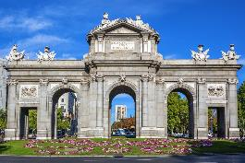 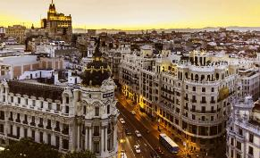 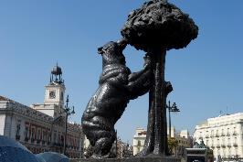

**day 1**

**private transfer** from Madrid airport to the hotel in Madrid.

**leisure time**, to enjoy the capital. watching a football match in Santiago Bernabeu or having a tour of the famous stadium could be a good plan in Madrid.

overnight at hotel in Madrid.

**day 2**

breakfast at the hotel.

**Toledo excursion** on regular basis.

*Toledo is one of the Spanish cities with the greatest wealth of monuments. known as the “****city of the three cultures****”, because Christians, Arabs and Jews lived together there for centuries, behind its walls Toledo preserves an artistic and cultural legacy in the form of churches, palaces, fortresses, mosques and synagogues.*

*this great diversity of artistic styles makes the old quarter of the capital of La Mancha a real* ***open-air museum****, which has led to it being declared a world heritage site.*

overnight at hotel in Madrid.

**day 3**

breakfast at the hotel.

**leisure time** in Madrid, enjoy the city, especially the liveliness during the night, the bars, the cafes.

overnight at hotel in Madrid.

**day 4**

breakfast at the hotel.

**Madrid sightseeing** based on a hop on- hop off bus.

*hop on the bus, put on your earphones, listen to the recorded commentaries and enjoy the streets, monuments and places of interest that you pass by. in addition, you will be able to hop off the bus wherever you want.*

*during the different historical periods the city grown from the old Hapsburg and bourbons quarters to the present city. highlights of the tour include* ***Gran Vía, Plaza de España, university, Moncloa, Hapsburg old quarter, Calle Mayor, Puerta del Sol, Puerta de Alcalá.***

overnight at hotel in Madrid.

**day 5**

breakfast at the hotel.

**day at leisure** to discover the city`s wonderful streets, plazas and corners. go shopping on the ever so lively Calle Fuencarral or Gran Via to finish your trip in style.

overnight at hotel in Madrid.

**day 6**

breakfast at the hotel and check out.

**private transfer** from the hotel to Madrid airport.

**end of services**

**prices**

|  |  |  |  |
| --- | --- | --- | --- |
| **price per person & package** | **Nov - Mar** | **Apr - Oct** | **Jul - Aug** |
| **standard class** | **305 €** | **350 €** | **305 €** |
| child standard price  (up to 12 yrs) | **135 €** | **155 €** | **135 €** |
| single supplement | **140 €** | **140 €** | **135 €** |
| **first class** | **375 €** | **420 €** | **345 €** |
| child first price  (up to 11 yrs) | **40 €** | **40 €** | **40 €** |
| single supplement | **216 €** | **250 €** | **182 €** |
| **superior class** | **525 €** | **660 €** | **535 €** |
| child superior price  (up to 11 yrs) | **40 €** | **40 €** | **40 €** |
| single supplement | **328 €** | **440 €** | **340 €** |

* prices per person based on double room & bb basis. taxes included. valid for minimum 2 traveling pax. prices for children sharing room with 2 adults.

* prices subject to availability and possible fluctuations in any of the requested services at the time of final booking.

**validity**: **until October 2020.**

inclusions:

|  |  |  |  |  |
| --- | --- | --- | --- | --- |
| **city & nights** | **transfers** | **Sightseeing on SIC basis** | **meals** | **24h. phone**  **assistance** |
| **5n Madrid** | private apt-htl-apt | hop on hop off bus one day ticket  half day Toledo excursion | breakfast |

prices do not include:

* flight tickets.
* tips and guests’ extras.
* any other service not mentioned on the programme/ itinerary described.
* **transportation to sightseeing meeting points is not included, we recommend the use of public transportation or taxi.**

|  |  |  |
| --- | --- | --- |
| Bern  **football tickets**  **on request** (prices from 48 € to 1.176 €) | C:\Users\marketing2\AppData\Local\Microsoft\Windows\INetCache\Content.Word\madrid-entrada-santiago-bernabeu.jpg  **Real Madrid stadium tour**  adult: 25 € child (6-13):18 € | C:\Users\marketing2\AppData\Local\Microsoft\Windows\INetCache\Content.Word\Flamenco-Madrid-400x300.jpg  **flamenco show & dinner in Madrid**  adult: 63 € (vegetarian menu and special children menu available) |

**optional supplements**:

* prices per person.